**Data Burger - Market and sales Analysis**

*“The burgers are important... but the data its more!”*

**Context**

Data Burger is a fast-food franchise focused on American-style burgers but always with a unique and daring twist. They want to introduce a new promotion next month, but there are currently three others in the market.

Data Burger wants to know how the active promotions are performing to make a business decision.

These three promotions are evenly distributed in the three markets, spread across several countries. The data provided by Data Burger pertains to this month, divided into weeks, with the revenue of each restaurant with its promotion.

We need to conduct an analysis of the current promotions based on sales, market, and promotion values. Adding more details about the stores or sales per week to make a decision for the next month.

*“Enjoy your data!... I mean, your meal!”*

**Work provided**

**Python Analysis**

- Data cleaning and EDA.

- Data visualization.

- Market analysis.

- Promotion comparison.

**SQL Queries**

1. What are the stores with the highest sales in the month?

2. And the top-performing stores in each market?

3. What is the amount collected for each promotion?

4. And the total amount of money collected this month?

5. Which market has the highest sales?

6. What are the weekly sales for each market?

7. Which countries have the highest sales (queries on countries)?

**Tableau**

- Visualization and dashboards.

- Data tracker displayed on a dashboard to assist the company in decision-making

- Step-by-step history of how the conclusion was reached.

**Market Analysis**

The food franchise Data Burger, present worldwide have 3 special promotions during the period of a month. My work its to analyze the sales and promotions and give some insights about the performance of each promotion to determine wich one will be dismissed for a new one.

After reaching all the data from this time, we have the next database:

*- country*

*- marketsize*

*- locationid*

*- ageofstore*

*- promotion*

*- week*

*- sales*

On the first aproach we can observe that the data dont have NaNs, so I proceeded to make the EDA of the data to have a full vision:

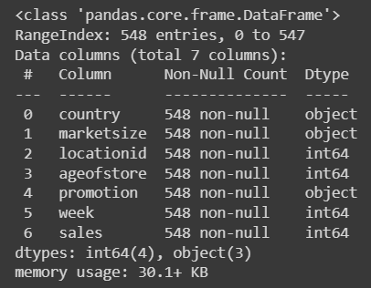

Next, I took a look on the numerical columns of the database:

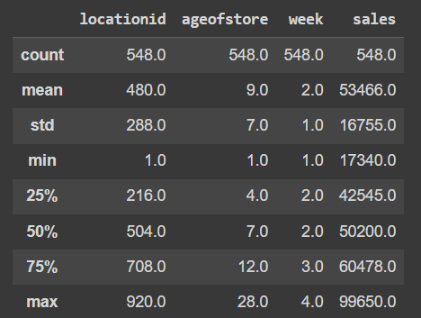

One of the important columns, the marketsize its distributed like this:

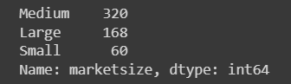

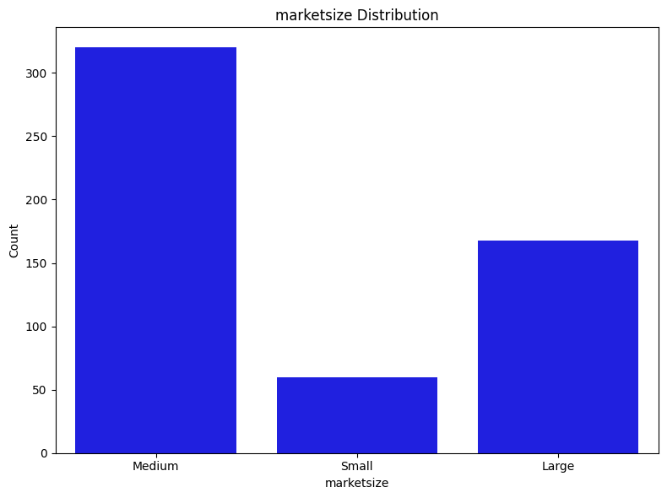

Surprisingly we have a lot of stores in markets considerated Medium. This can indicate the relation between competitors, sales and countries.

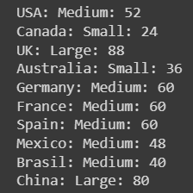

- Small markets comprise countries with 1 to 39 stores.

- Medium markets encompass countries with 40 to 79 stores.

- Large markets consist of countries with 80 or more stores.

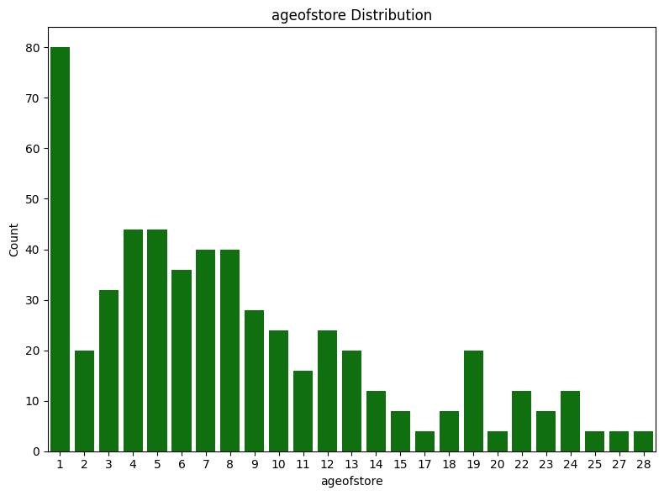

After analyzing the markets and stores we can take a look on the sales and promotions. The two main values on this database.

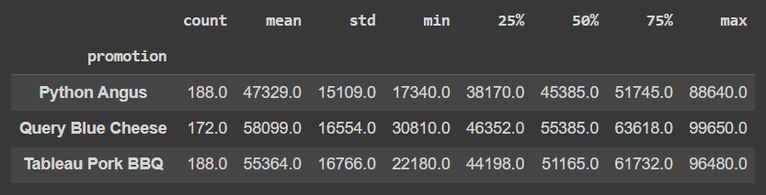

With this datawe can see that the Query Blue Ceese have the best mean in sales, but we need to take the consideration that it has the less amount of distribution worldwide.

In the other two, the mean its close to each other with the same amount of distribution.

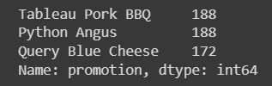

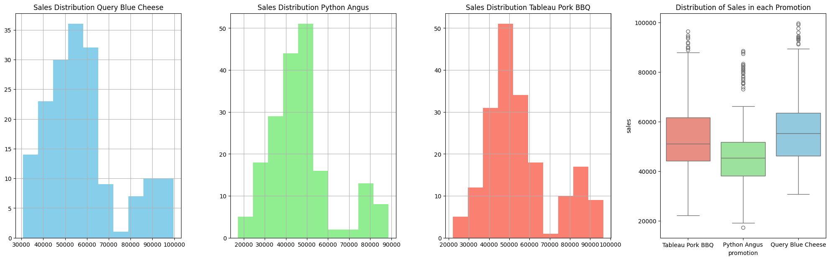

**Promotion comparison**

The next step its to compare the promotions to take the insight of the performance of each of them.

I compared the 3 promotions with ANOVA method to determine how the performance its going taking the sales as the main value.

F Estadistic: 21.953

P Value: 6.766100696713364e-10

There are significant differences between at least two groups.

Given that the p-value is significantly less than 0.05, we can reject the null hypothesis that there are no significant differences between the groups. This suggests that at least one of the groups differs significantly in terms of sales compared to the other groups.

With the Tukey test the comparison between the 3 promotions look this way:

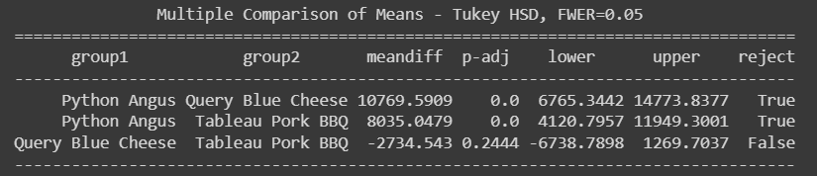

After this results we can conclude:

- The average difference between sales of Python Angus and Query Blue Cheese is significantly different, with Python Angus having significantly higher sales than Query Blue Cheese.

- There is also a significant difference between sales of Python Angus and Tableau Pork BBQ, with Python Angus having significantly higher sales than Tableau Pork BBQ.

- However, there is no significant difference in sales between Query Blue Cheese and Tableau Pork BBQ.

These results suggest that the promotions Python Angus and Query Blue Cheese have significantly different performance in terms of sales, with Python Angus having significantly higher sales than Query Blue Cheese. Additionally, Python Angus also has significantly better performance compared to Tableau Pork BBQ. On the other hand, there is no significant difference in sales between Query Blue Cheese and Tableau Pork BBQ.

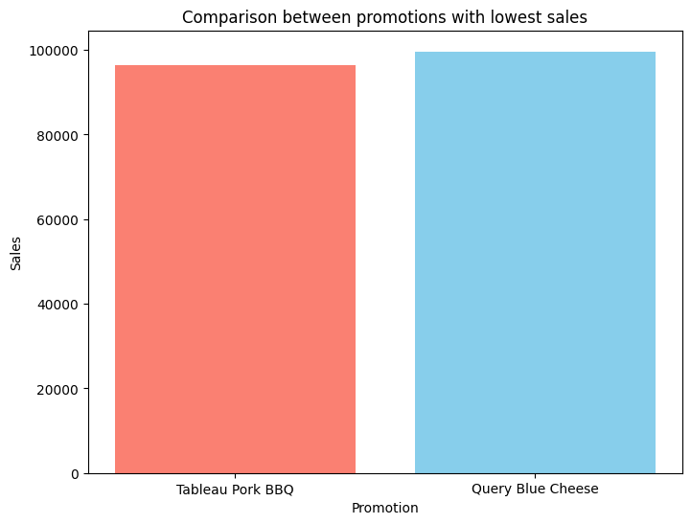

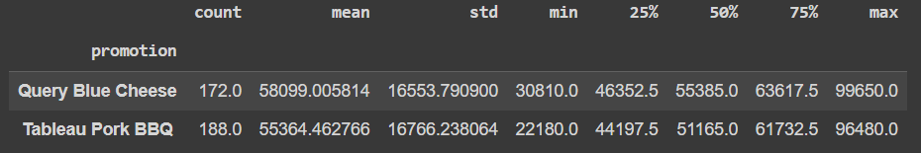

From the provided data, we can draw several conclusions about the two promotions with the lowest sales:

Average Sales: The Query Blue Cheese promotion has a higher average sales (approximately 58099.01) compared to the Tableau Pork BBQ promotion (approximately 55364.46).

Sales Dispersion: Both promotions have similar dispersion in their sales, as reflected in the standard deviation. This means that sales tend to vary in a similar range around the mean for both promotions.

Sales Range: The Query Blue Cheese promotion has higher sales in both the 25th and 75th percentiles compared to Tableau Pork BBQ. This suggests that sales tend to be higher for Query Blue Cheese in most cases, although there are some exceptional observations of higher sales for Tableau Pork BBQ.

**Final insights**

- The promotions sorted by sales are:

1. Python Angus
2. Query Blue Cheese
3. Tableau Pork BBQ

After the analysis we recomend to dismiss the Tableau Pork BBQ.

- Some markets are weaker than others. Canada and USA are really low compared with countries like UK. We recomend to improve the promotions on Canada and invest in North America to boost the sales. Otherwise, UK and China are our biggest markets in terms of sales and stores.

- The last year we doubled the number of new stores compared with the last 5 to 10 years.